THANKSGIVING
Directions: Fill in the blanks while you listen to the presentation.

Thanksgiving is a _________________________ to give thanks at the end of the harvest season. Thanksgiving is the fourth Thursday in ____________________________ in the US.

On Thanksgiving, we remember the difficulties the ____________________________faced when they came to North America. The Pilgrims are people from _________________________ that travelled to North America to find religious freedom. The Pilgrims left Holland to go to North America in a ship called _________________________________. The Pilgrims named their settlement Plymouth.

It was very cold during the winter and the Pilgrims did not have enough to eat. Many people ________________________. A group of Native Americans helped the Pilgrims. Squanto was a Native American. He taught the Pilgrims how to plant crops, ___________________________, and ________________________. Squanto helped the Pilgrims and their harvest was very good. They had extra ____________________________ for the winter.

The Pilgrims celebrated the good harvest with the Native Americans. The first Thanksgiving celebration lasted for __________________________ days.

Today, Americans celebrate Thanksgiving by getting together with family and friends to eat a big ________________________. People talk about what they are ________________________ for during Thanksgiving dinner.

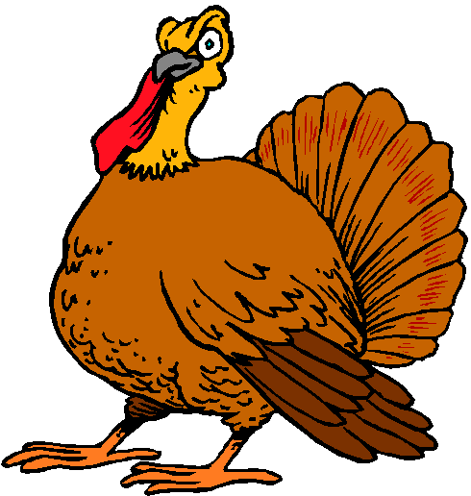
Macy´s puts on a big _________________________________ in New York City for Thanksgiving. _____________________________________ is a sport that people play on Thanksgiving.

Directions: Answer the questions about Thanksgiving after you listen to the presentation.
- What countries celebrate Thanksgiving?

- Who were the Pilgrims? Where were they from?

- Why did the Pilgrims sail to North America?

- Where did the Pilgrims land when they arrived in North America?

- Why did many Pilgrims die after they arrived in North America?

- Why was the first Thanksgiving celebrated?

- How do Americans celebrate Thanksgiving today?

- What foods do Americans eat on Thanksgivng?

- What is a turkey pardon?

- Write two examples of Thanksgiving traditions.

