**If you could meet someone famous, who would you meet?**

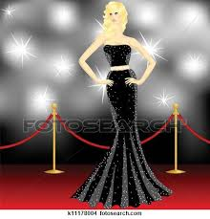

**If you went on a desert island, what three books/films would you take with you?**

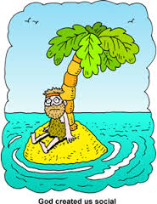

**Where would you live if you could live anywhere in the world?**

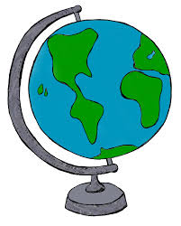

**What would be the very first thing to buy if you won the lottery?**



**If you could travel in time, would you go to the past or the future?**

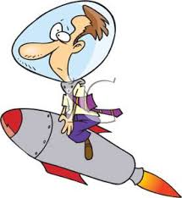

**What superpower would you like to have if you could choose?**

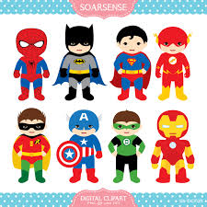

**If you found Aladdin’s lamp, what would be your three wishes?**

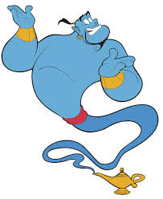

**Where would you go on holiday if you could go anywhere?**

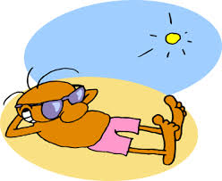

**What would you do if you saw your friend cheating on a test?**



**What would you change about your personality if you could choose one thing?**



**What would you do if your friend invited you for dinner and served something you hate?**



**What would you do if you saw your friend shoplifting?**

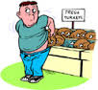

**Where would you be if you didn’t have to be here now?**



**If you won a lot of money, how much would you give to friends, family and charity?**



**Would you tell the truth to your friend if you knew it would hurt him/her?**

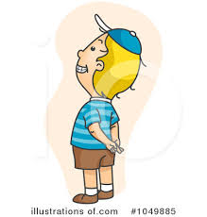

**What would you change about your appearance if you could choose one thing?**

